SimDif Website Creation

Home Page:
Create a page to tell about your store. Include a picture of the poster you create. The poster should be colorful and include a creative antique shop name.
Items For Sale:
Each group member should include his/her action figure and 3-5 items from the 1700s-1800s (the time period of your historical figure). Partners will include 2 action figures plus 6-10 items. Groups of three will include 3 action figures plus 9-15 items.
*Each item must include a picture, a title of the item, a one-sentence description of the item (including 2-4 adjectives for each) and a price.
Tax and Shipping Page:
At the top of this page, assign tax to be 8.25% and tell your shipping charge.
*Each group member will write the calculation of 3 or more items from your website plus tax, plus shipping. Take a picture of each one and add to this page. *Don’t forget to sign your name to it!
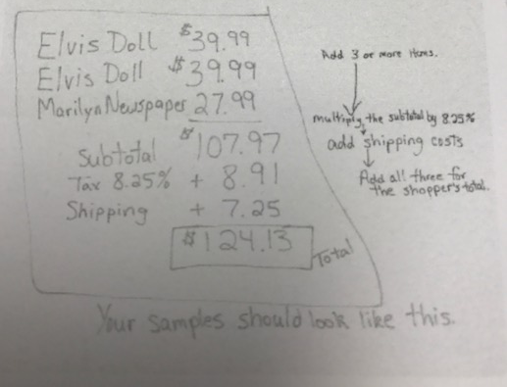
Progress Blog Page:
Create this new page as a “JOURNAL.” Each day at the end of the period, a different group member should bog about the progress made by the group that day. It should include what each person completed that day and end with your name. – Mrs. Woodard (do not include last names)
About Us:
Include a picture and the autobiography you wrote on this page. The picture can be you or a hobby you have if you do not want to include your picture. Do not put Paradise or your last names on this page!
*Type a creative slogan to go at the bottom of each page.
His

