Semester TEST Project
You will write a creative children’s story. You must have at least two characters that have a conversation somewhere in your story. You must use one of the provided themes or have one approved by Mrs. Woodard. After you write the story, you will proofread it and make it into a book.

Themes to choose from:
- If you don’t like where you are, pick a new route and keep going.
- Be yourself because there is no one like you.
- Treat others the way you want to be treated.
- Be yourself because an original is worth more than a copy.
- Don’t sweat the small stuff.
- Slow down and smell the roses.
*If you choose a truism from your reading journal, please have me approve it.

Due May 3
Daily Grade – “Story Planning Sheet”
Complete the worksheet as a prewriting exercise.

Due May 5
Daily Grade – Rough draft: 1 ½-3 pages handwritten
20 points Introduction paragraph – catch the reader’s attention; introduce the main character and setting (4 or more sentences)
60 points Middle paragraphs
- Character must face a conflict
- Character resolves the problem
- Must have dialogue
- Include one example of figurative language (simile, hyperbole, etc.)
20 points Conclusion paragraph – explain the theme/moral/lesson learned (3 or more sentences in conclusion paragraph)

Due May 11
Daily Grade – Book draft:
On a clean sheet(s) (folded twice into four equal parts) draft your book. You should plan your cover page and 4-8 inside pages with pictures.

Due Friday, May 20
We will present these to the class on semester test day.
Semester Test Grade: book with typed story
20 points Front/Back Cover - creative title, author’s name, neat, colorful, includes a picture, (scrapbook paper or construction paper is recommended for this)
20 points Inside – 4-8 pages, at least three different pictures (colored and neat) and a picture on each page
20 points Inside – neat or typed words, spelling and grammar are correct
10 points Introduction – catch the reader’s attention; introduce the main character and setting
20 points Middle – conflict, resolution, dialogue, figurative language
10 points Conclusion – explain the theme/moral/life lesson

Children’s book story starter ideas:
http://www.scholastic.com/browse/subarticle.jsp?id=2754
1. "Once upon a time, in a deep dark wood, in a teeny tiny cottage with a straw roof, lived a big rat. His name was Claude." -- from Tomie dePaola, children's book author
2. "Deep, deep down in the ocean as I was minding my own business..." -- from Lily Wong, professor, Southeast Asia Union College
3. "Way back in the back hills where even the ants didn't go, I remember..." -- from Jerry Tello, author and education consultant
4. "In old grandmother's trunk there was a ..." -- from Rebeca Barrera, president, National Latino Children's Institute
5. "There once was a rabbit who loved to dance." -- Laura Sims, storyteller, author, and educator
6. "My grandmother used to tell me home is where the heart is. I did not understand what she meant by that until one stormy night when ..." -- from Deborah Eaton, president, National Association for Family Child Care
7. "Long ago, in a faraway place, there was a land filled with wonder. In this fantastic place there was a little girl. She was very special, for she had a magic ..." -- from Robert Kikuchi-Yngojo and Nancy Wang, members of Eth-Noh-Tec, an Asian storytelling troupe
8. "It started out just like any other school day. I finished the last soggy pieces of cereal from my bowl full of milk. (I always pour too much!) But as I grabbed my coat and ran out the door, I couldn't believe my eyes!" -- from Marian Wright Edelman, president and founder, Children's Defense Fund

Go to http://www.bookweekonline.com/story-starters to find some other story starters.

Check out these webpages to give you story starters:

http://www.scholastic.com/teachers/story-starters/

http://www.creative-writing-now.com/story-starters.html

http://www.thestorystarter.com/jr.htm

http://www.writingprompts.net/7th-grade/

Or these picture prompts:

http://www.notsowimpyresources.com/2012/02/picture-prompt-linky-party.html

http://www.cnn.com/2015/01/02/travel/gallery/travel-photo-of-the-day/

Or try some of the prompts below:
Childhood Piece of Clothing You're rummaging through an old tub of clothes from your childhood that your parents had stored away in their attic. As you search you find one particular piece that you remember as your favorite. When you hold it in your hands, you're magically transported back to the moment you got that piece of clothing...

Anyone But Me You've had a rough day at work. You head home and go straight to bed, mumbling, "I wish I'd wake up tomorrow and be anyone but me," before dozing off. When you wake up in the morning, your dream has come true, as you quickly realize that you are not you—you are someone else...

Private Eye You're a private investigator who is down on his or her luck and hasn't had a client in months. Suddenly the phone rings. It's a kid. The kid proposes a silly case to you. Normally you wouldn't take such a ridiculous job (from a kid, no less), but you need the work, so you...

It’s You — But It Isn’t You're a regular commenter on a website about a hobby you are passionate about. You've been posting for years and have made many friends. Suddenly one day, you hop on the site and notice there are several comments from you—but you didn't write them! You attempt to delete them, but you can't. Worse yet,...

Scavenger Hunt You're involved in a scavenger hunt—boys versus girls—and you take off to help your team collect every item on the list. The first several items are relatively easy but the last item is very unusual. But, upon reading the last item, you know exactly where to find it. The only problem is that it...

Wizards & Warriors You're playing a video game called Wizards & Warriors when, suddenly, lighten strikes the house, scaring you and causing you to black out. When you wake up, you're trapped inside the game. The only items you have is a sword, a backpack and a note attached to your shirt that reads, "Beat me and...

Your Family’s Life Depends on It Your best friend knocks on your door one afternoon. You open it and he or she is dressed in a strange costume. Before you can say anything, your friend hands you a sword and says, "I need your help. Your family's life depends on it." Just then, your friend opens what looks to be...

Snow Shoveling Showdown You're outside shoveling your own driveway when you decide, as a kind gesture, to shovel your neighbor's driveway too. Just then a group of teenagers with shovels show up and threaten you, claiming that this is "their turf." What do you do?

Dentist Disaster You go in for a rather complex dental procedure and the dentist has to put you under in order to complete it. When you wake up, though, you are no longer in the dentist office. You are on a train with a briefcase handcuffed to your wrist. Just as you are soaking in this...

Valentine’s Day Escape Plan Your are going on a blind date for Valentine's Day. In case the date is a dud, you have your best friend on standby. Your friend is to call you at 9:30 on the dot. If the date is going well, you answer and use the phrase "I already took care of that." If...

Ghostbuster For Hire You've been out of work for a few months and respond an unusual ad online that reads: "Team seeking full-time associate who isn't afraid of ghosts." They call and tell you to come in. Intrigued (and desperate for work), you go to their office and get hired on the spot. Moments later, there's a...
- You’re digging in your garden and find a fist-sized nugget of gold.
- The asteroid was hurtling straight for Earth…
- A kid comes out of the school bathroom with toilet paper dangling from his or her waistband.
- There’s a guy sitting on a park bench reading a newspaper…
- He turned the key in the lock and opened the door. To his horror, he saw…
- Silvery flakes drifted down, glittering in the bright light of the harvest moon. The blackbird swooped down…
- The detective saw his opportunity. He grabbed the waitress’s arm and said…
- There are three children sitting on a log near a stream. One of them looks up at the sky and says…
- There is a magic talisman that allows its keeper to read minds. It falls into the hands of a young politician…
- And you thought dragons didn’t exist…
- Write about nature. Include the following words: hard drive, stapler, phone, car, billboard.
- You walk into your house and it’s completely different — furniture, decor, all changed. And nobody’s home.
- The most beautiful smile I ever saw…
- A twinkling eye can mean many things. Start with a twinkle in someone’s eye and see where it takes you.
- Have you ever been just about to drift off to sleep only to be roused because you spontaneously remembered an embarrassing moment from your past?

NAME: ____________
Daily Grade – Rough draft: 1 ½-3 pages handwritten
_____20 points Introduction paragraph – catch the reader’s attention; introduce the main character and setting (4 or more sentences)
_____60 points Middle paragraphs
____Character must face a conflict
____Character resolves the problem
____Must have dialogue
____Include one example of figurative language (simile, hyperbole, etc.)
_____20 points Conclusion paragraph – explain the theme/moral/lesson learned (3 or more sentences in conclusion paragraph)

_____TOTAL GRADE

NAME: ____________
Daily Grade – Rough draft: 1 ½-3 pages handwritten
_____20 points Introduction paragraph – catch the reader’s attention; introduce the main character and setting (4 or more sentences)
_____60 points Middle paragraphs
____Character must face a conflict
____Character resolves the problem
____Must have dialogue
____Include one example of figurative language (simile, hyperbole, etc.)
_____20 points Conclusion paragraph – explain the theme/moral/lesson learned (3 or more sentences in conclusion paragraph)

_____TOTAL GRADE
Name:__________________
Semester Test Grade: book with typed story
_____20 points Front/Back Cover - creative title, author’s name, neat, colorful, includes a picture,
_____20 points Inside – 4-8 pages, 4-8 pages, at least 3 pictures (colored and neat)
_____20 points Inside – neat words, spelling and grammar are correct
_____10 points Introduction – catch the reader’s attention; introduce the main character and setting
_____20 points Middle – conflict, resolution, dialogue, figurative language
_____10 points Conclusion – explain the theme/moral/life lesson
_____TOTAL GRADE

Name:__________________
Semester Test Grade: book with typed story
_____20 points Front/Back Cover - creative title, author’s name, neat, colorful, includes a picture,
_____20 points Inside – 4-8 pages, 4-8 pages, at least 3 pictures (colored and neat)
_____20 points Inside – neat words, spelling and grammar are correct
_____10 points Introduction – catch the reader’s attention; introduce the main character and setting
_____20 points Middle – conflict, resolution, dialogue, figurative language
_____10 points Conclusion – explain the theme/moral/life lesson

_____TOTAL GRADE

Name: __________________
DUE at the end of the period on Tuesday, May 3, 2016
Creative Children’s Story Planning Sheet

Complete the following planning sheet. Use one of the themes provided or a truism you wrote in your reading journal. Be creative with this children’s book.

What will the TITLE be?

________________________________________________

THEME:

What is the theme of your story? What will the character learn?
________________________________________________________________________________________________
SETTING:

What is the setting of your story? (time and place)

________________________________________________________________________________________________________________________________________________

CHARACTERS:

Describe your main character (appearance and personality)-
________________________________________________________________________________________________
What conflict will the main character face, and how will she/he deal with it and resolve the problem?

________________________________________________________________________________________________
Describe your other characters (appearance and personality)-
________________________________________________________________________________________________ ________________________________________________________________________________________________ ________________________________________________
TONE/MOOD:
What is the tome/mood of your story?
________________________________________________

PLOT/CONFLICT

Draw a plot mountain of your story. Show at least two rising actions, one climax, and one falling action.

DIALOGUE:
A conversation can help move the action along. Write a conversation between two or more of your characters. Each character must speak at least twice and DO NOT use “said.”

________________________________________________________________________________________________________________________________________________
________________________________________________________________________________________________________________________________________________

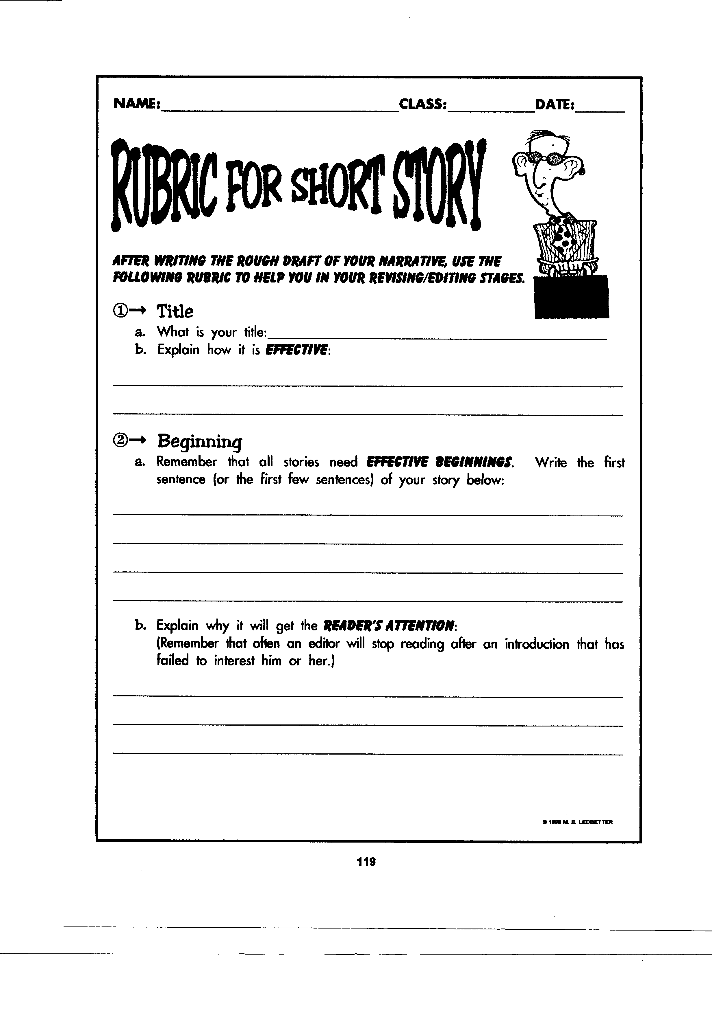
DUE at the end of the period on Tuesday, May 3, 2016

Complete this panning sheet. Use one of the themes I have provided or one of your own. Create your own story.
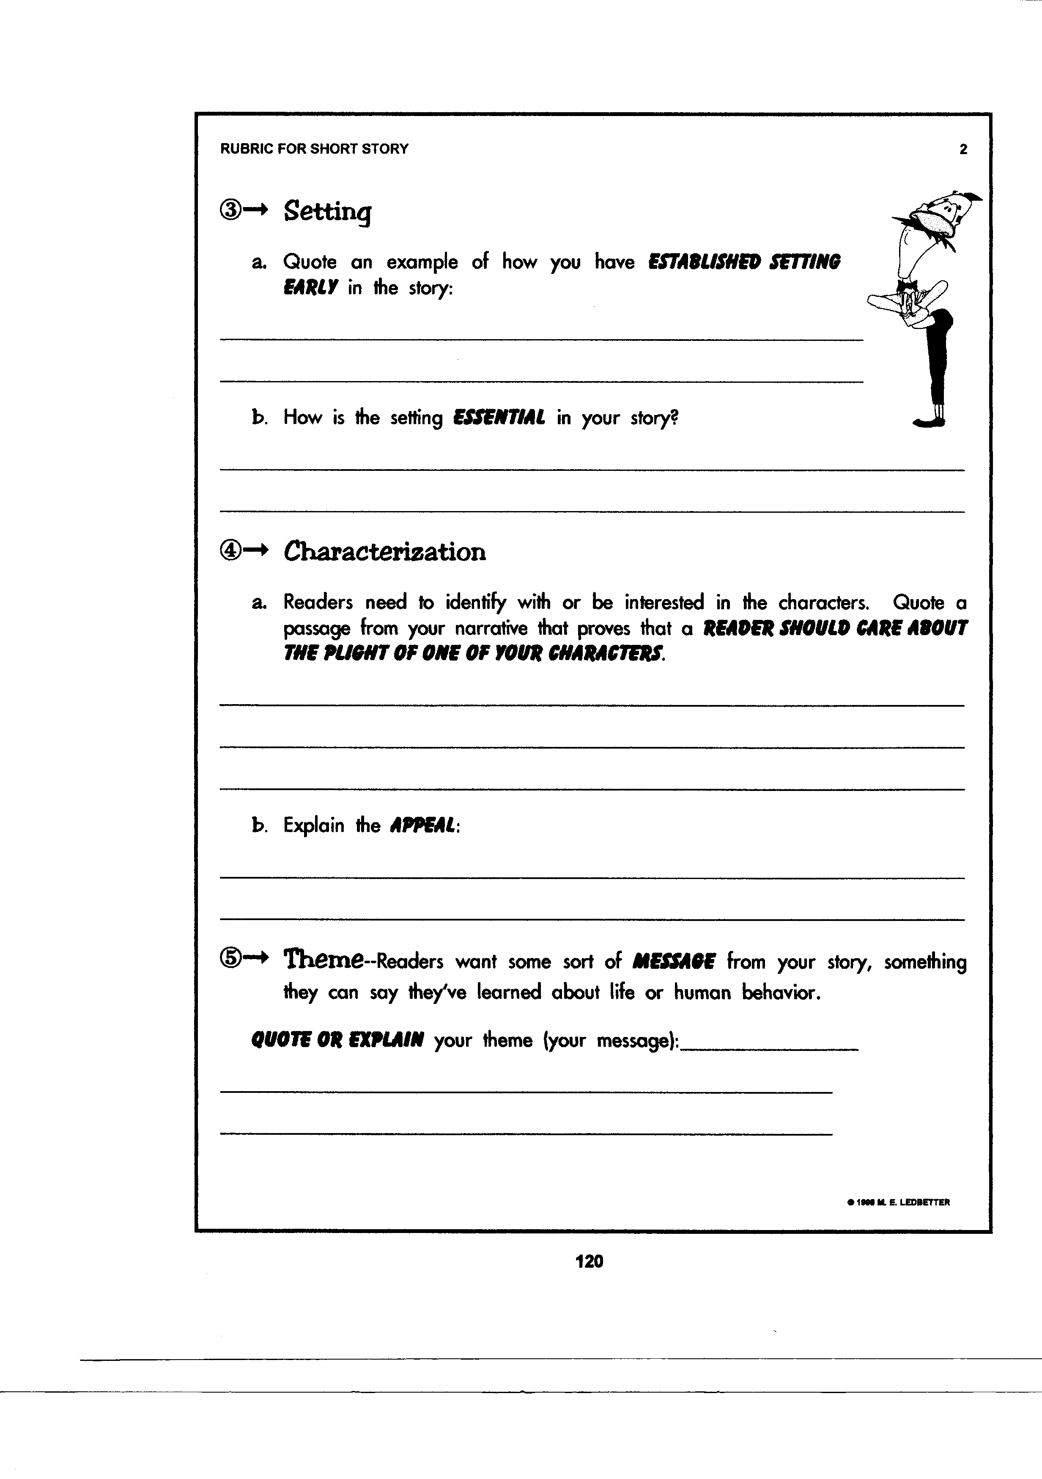

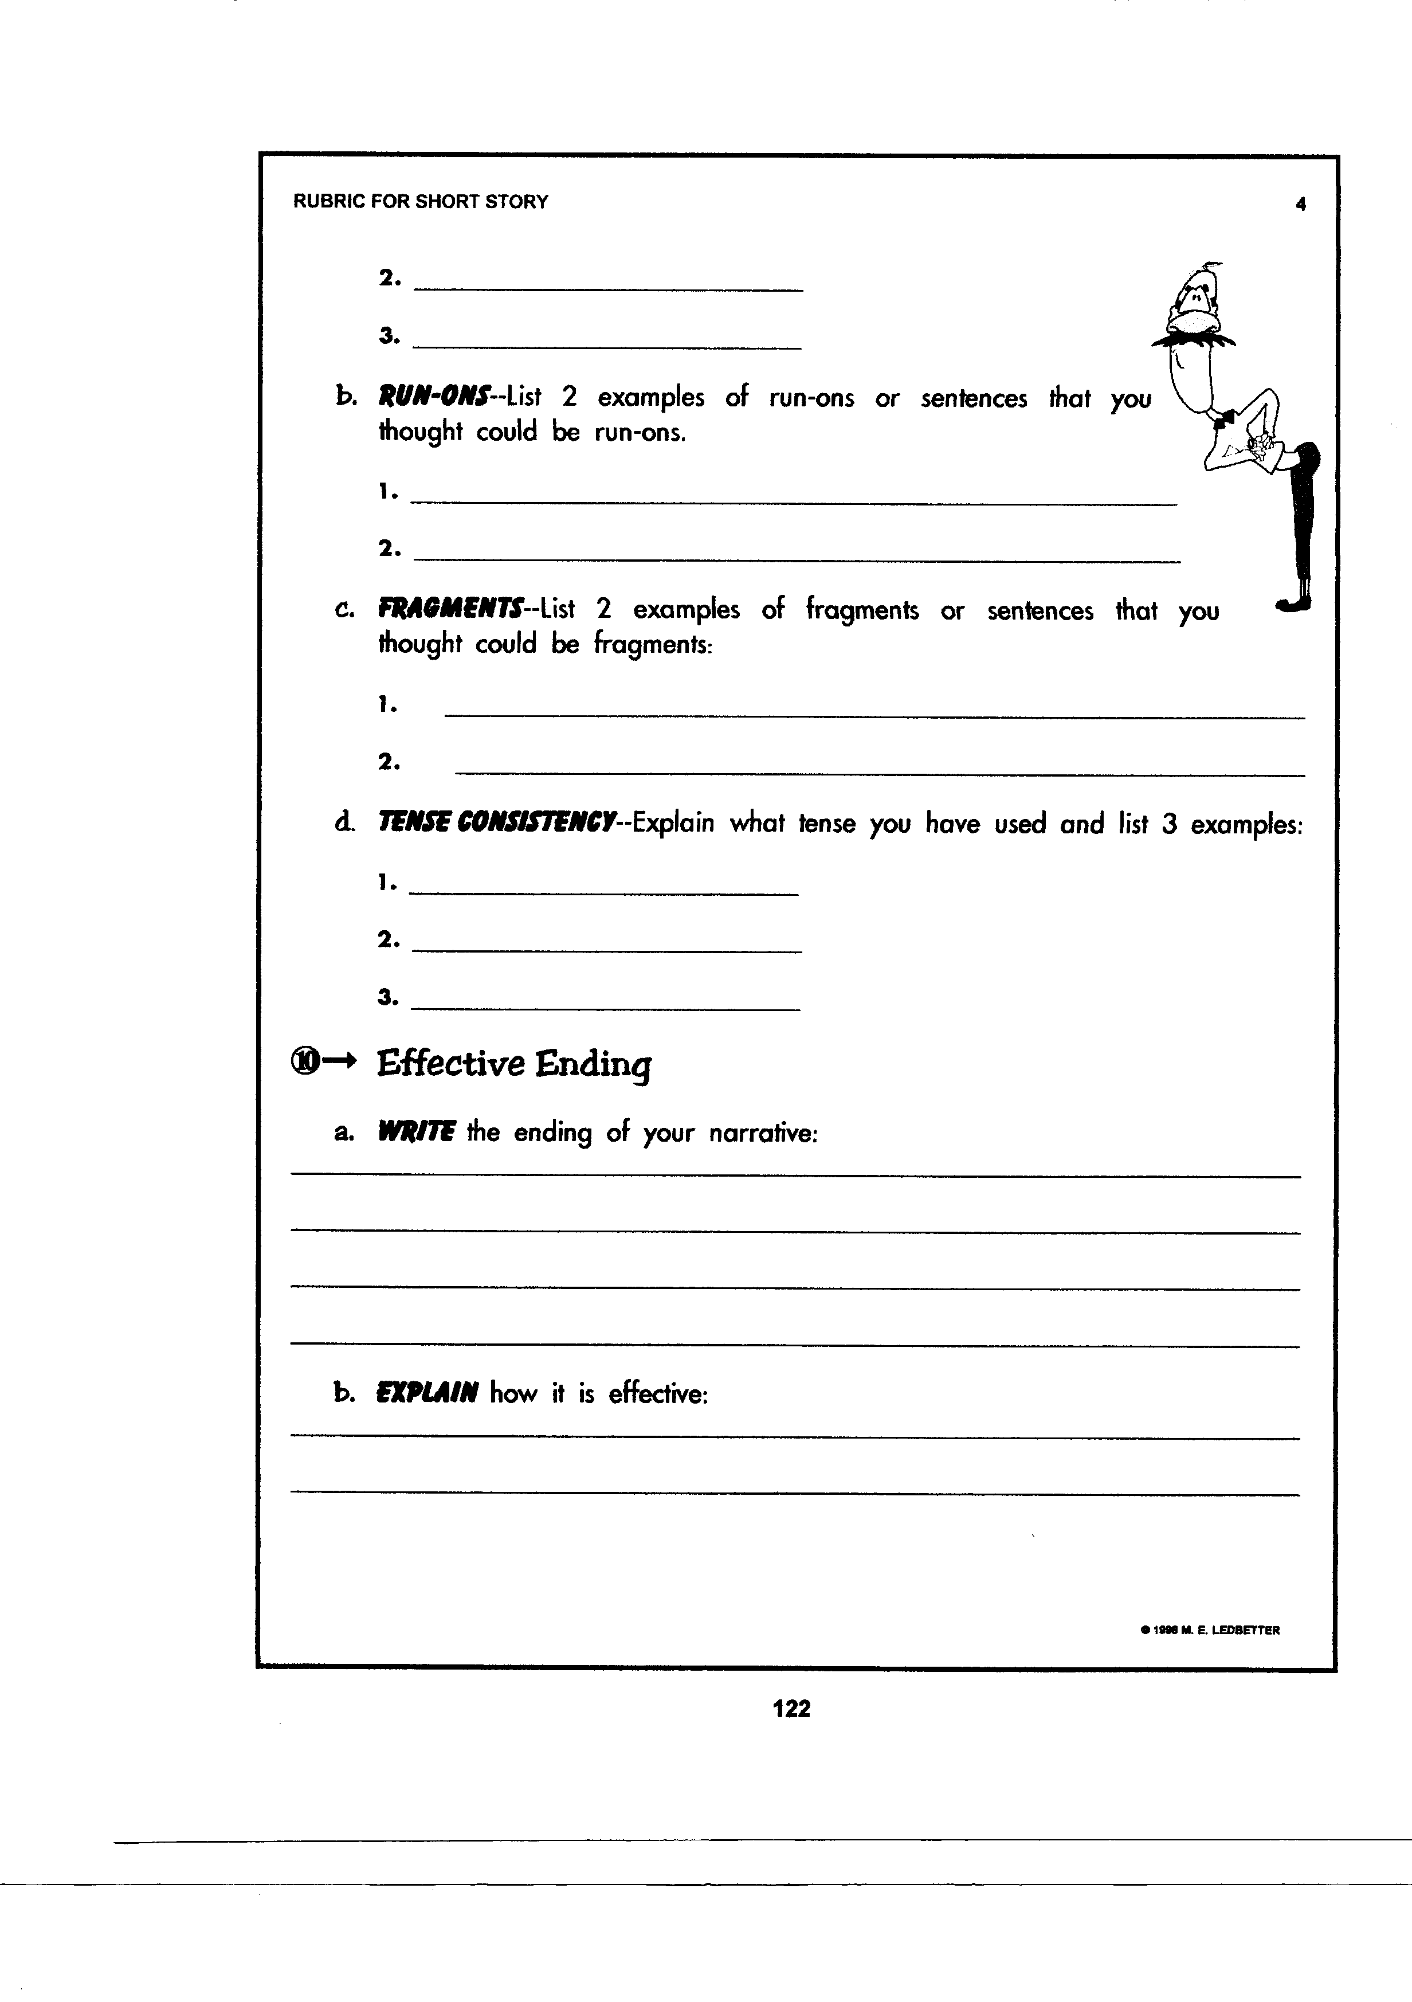
Describe the conflict the character will face and how he/she will deal with it.

Describe your main character (appearance, personality, etc).
will
Write
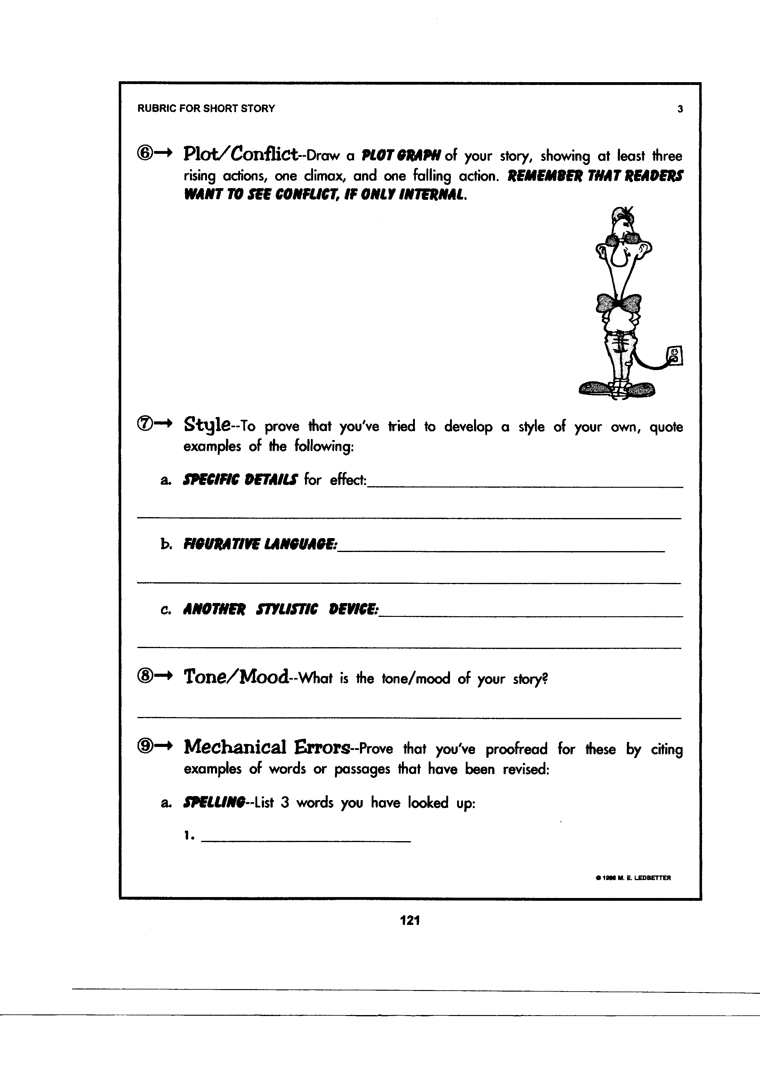

You must include figurative language in your story. Write an example of what you will use. (Personification, metaphor, hyperbole, simile, idiom, etc.
Include how the conflict is resolved.

Will use
- Conversation: write a dialogue between the main character and another character. Each character must speak twice and do not use the word “said”.

____________________________________________________________________________________

____________________________________________________________________________________

____________________________________________________________________________________

____________________________________________________________________________________

____________________________________________________________________________________

____________________________________________________________________________________

____________________________________________________________________________________

____________________________________________________________________________________

