Name: __________________
DUE at the end of the period on Tuesday, May 3, 2016
Creative Children’s Story Planning Sheet

Complete the following planning sheet. Use one of the themes provided or a truism you wrote in your reading journal. Be creative with this children’s book.

What will the TITLE be?

________________________________________________

THEME:

What is the theme of your story? What will the character learn?
________________________________________________________________________________________________
SETTING:

What is the setting of your story? (time and place)

________________________________________________________________________________________________________________________________________________

CHARACTERS:

Describe your main character (appearance and personality)-
________________________________________________________________________________________________
What conflict will the main character face, and how will she/he deal with it and resolve the problem?

________________________________________________________________________________________________
Describe your other characters (appearance and personality)-
________________________________________________________________________________________________ ________________________________________________________________________________________________ ________________________________________________
TONE/MOOD:
What is the tome/mood of your story?
________________________________________________

PLOT/CONFLICT

Draw a plot mountain of your story. Show at least two rising actions, one climax, and one falling action.

DIALOGUE:
A conversation can help move the action along. Write a conversation between two or more of your characters. Each character must speak at least twice and DO NOT use “said.”

________________________________________________________________________________________________________________________________________________
________________________________________________________________________________________________________________________________________________

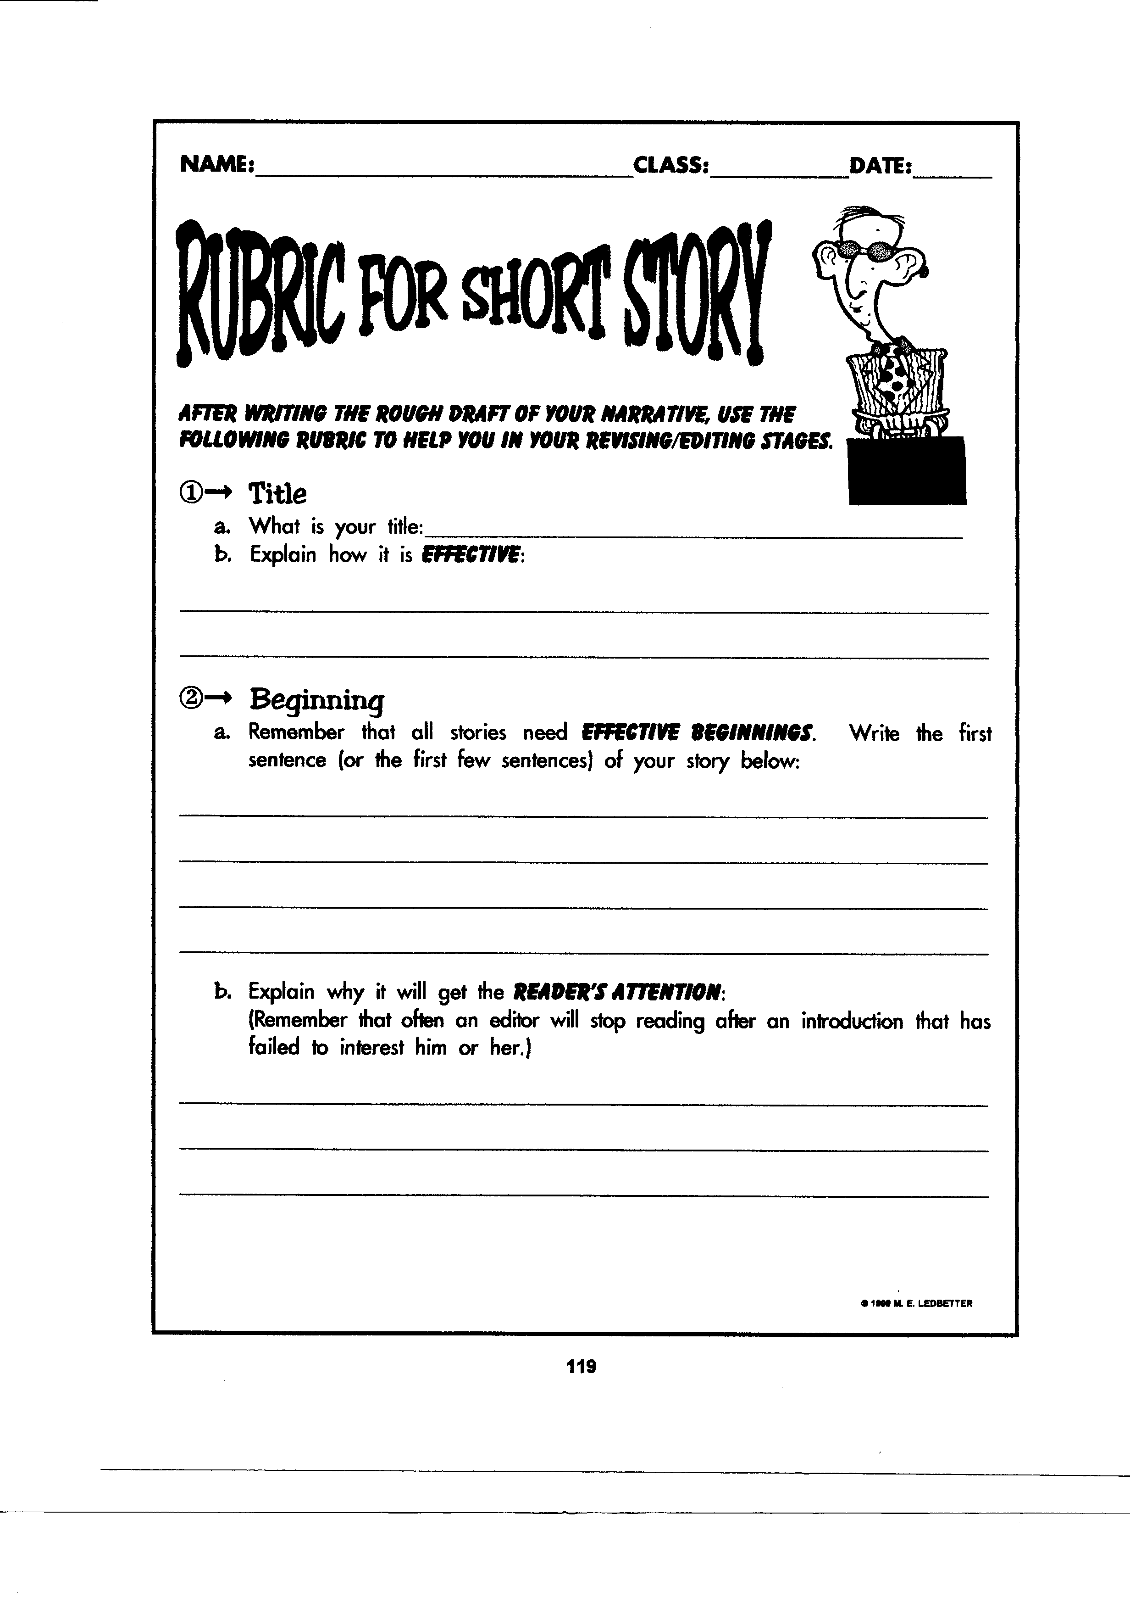
DUE at the end of the period on Tuesday, May 3, 2016

Complete this panning sheet. Use one of the themes I have provided or one of your own. Create your own story.
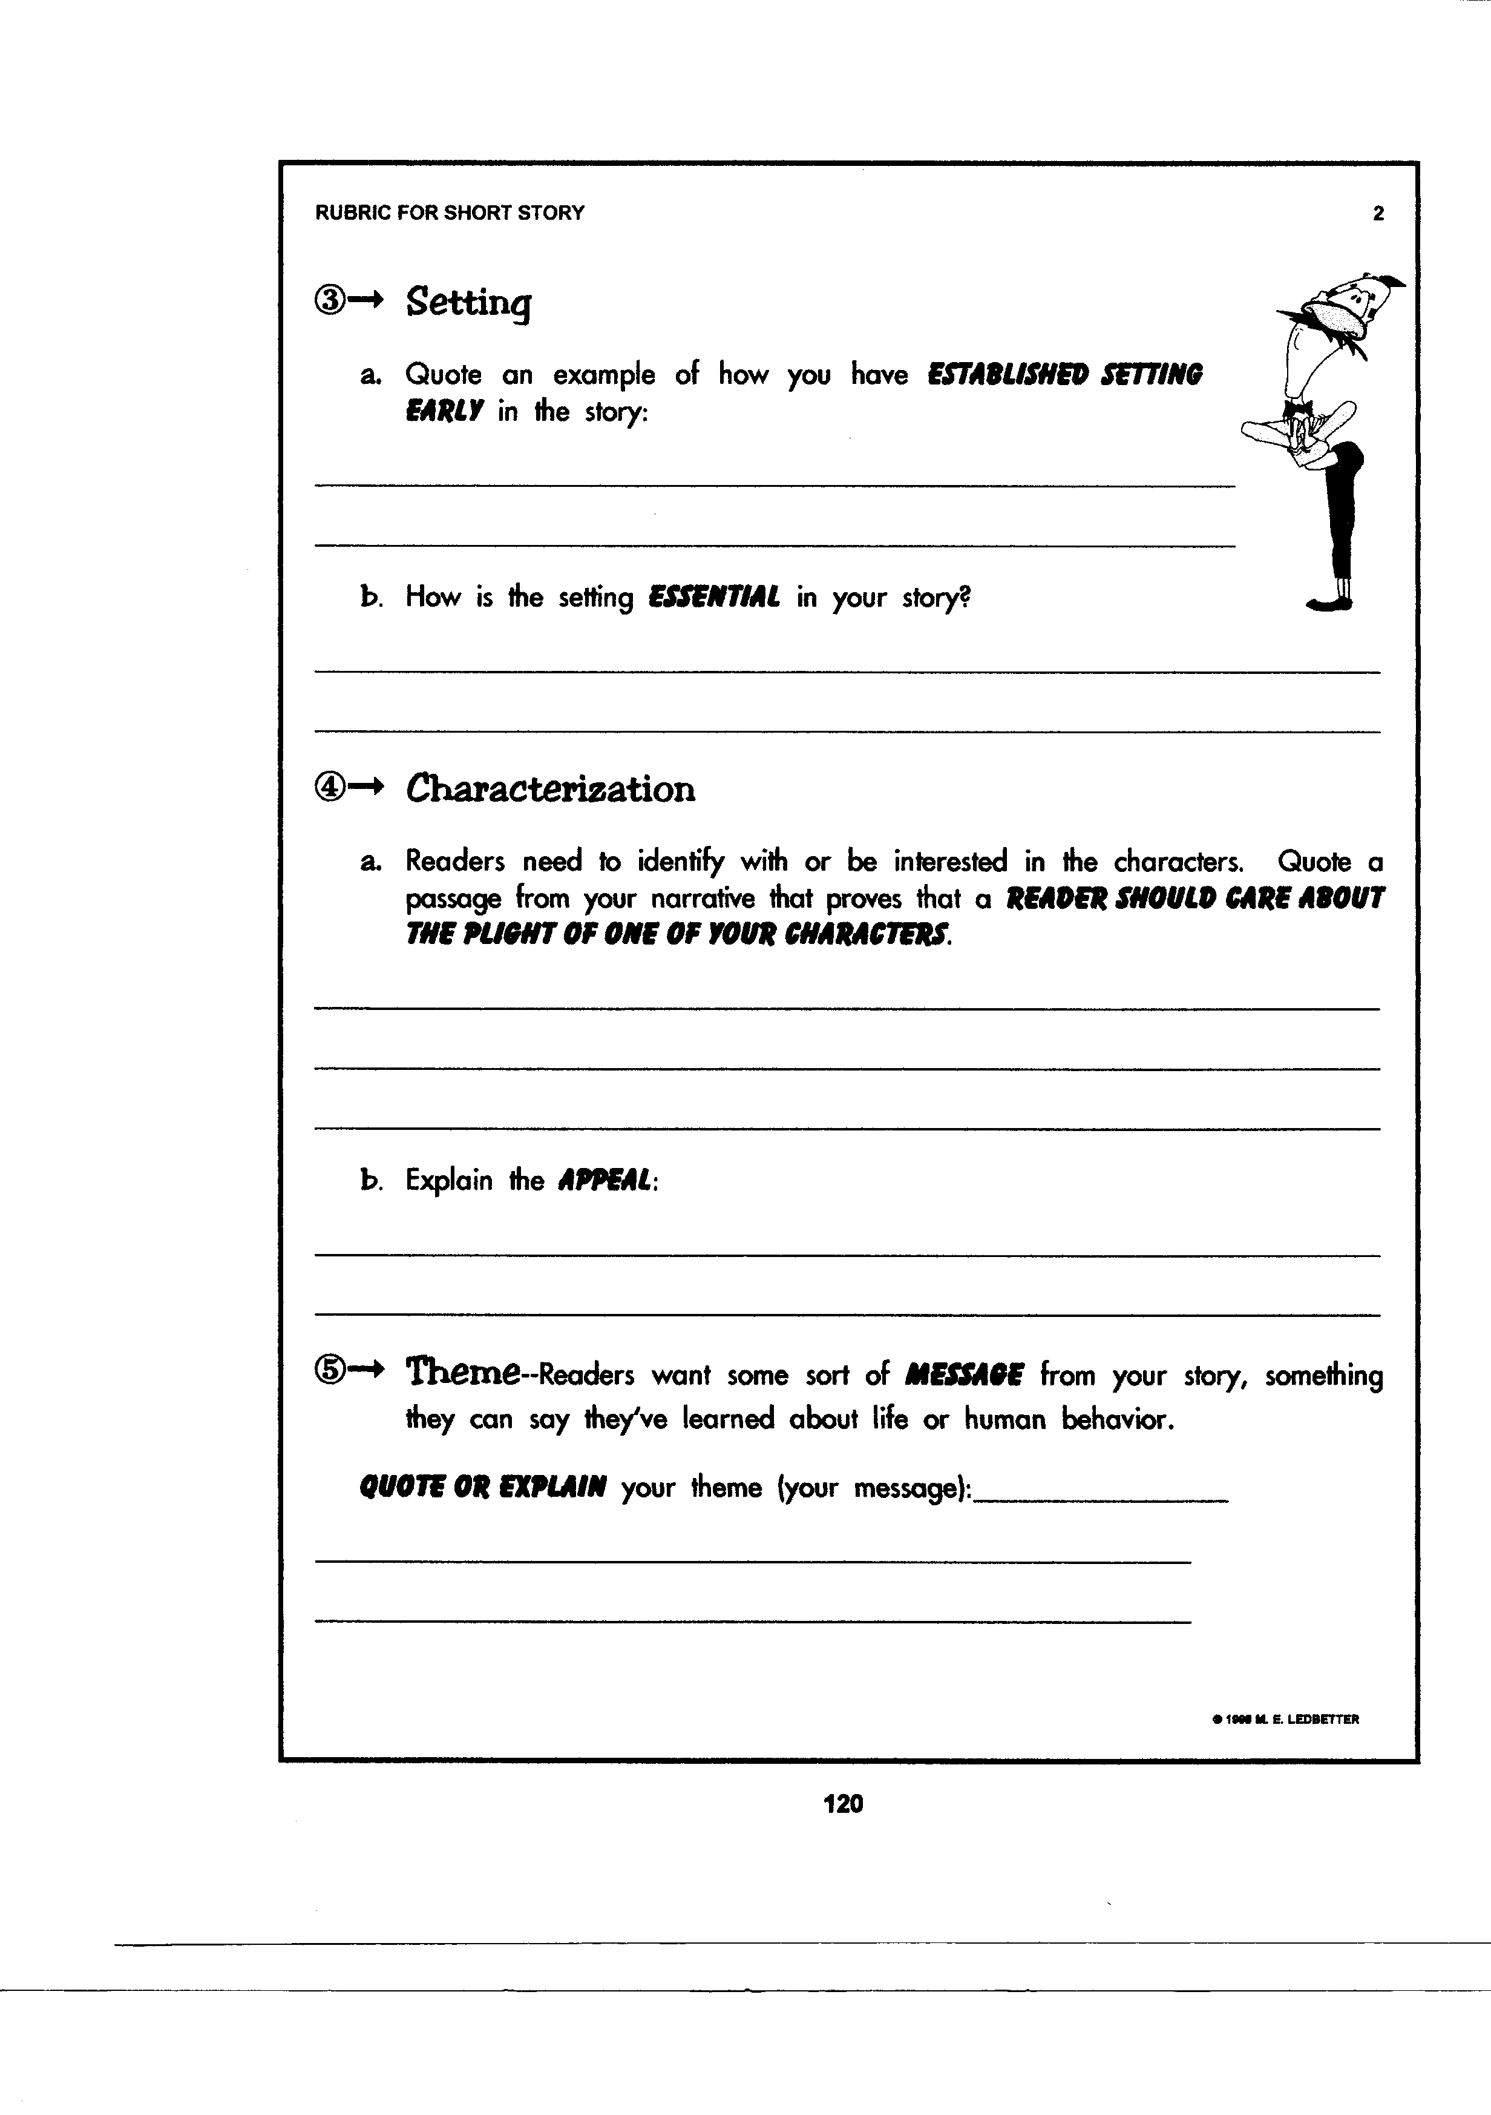

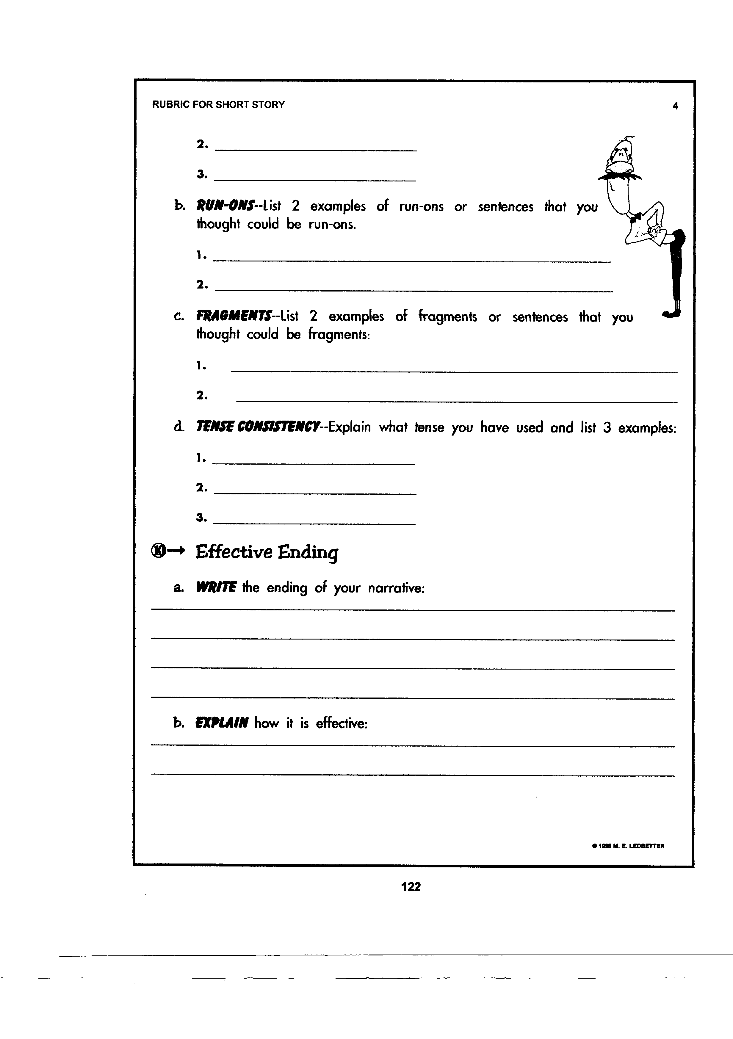
Describe the conflict the character will face and how he/she will deal with it.

Describe your main character (appearance, personality, etc).
will
Write
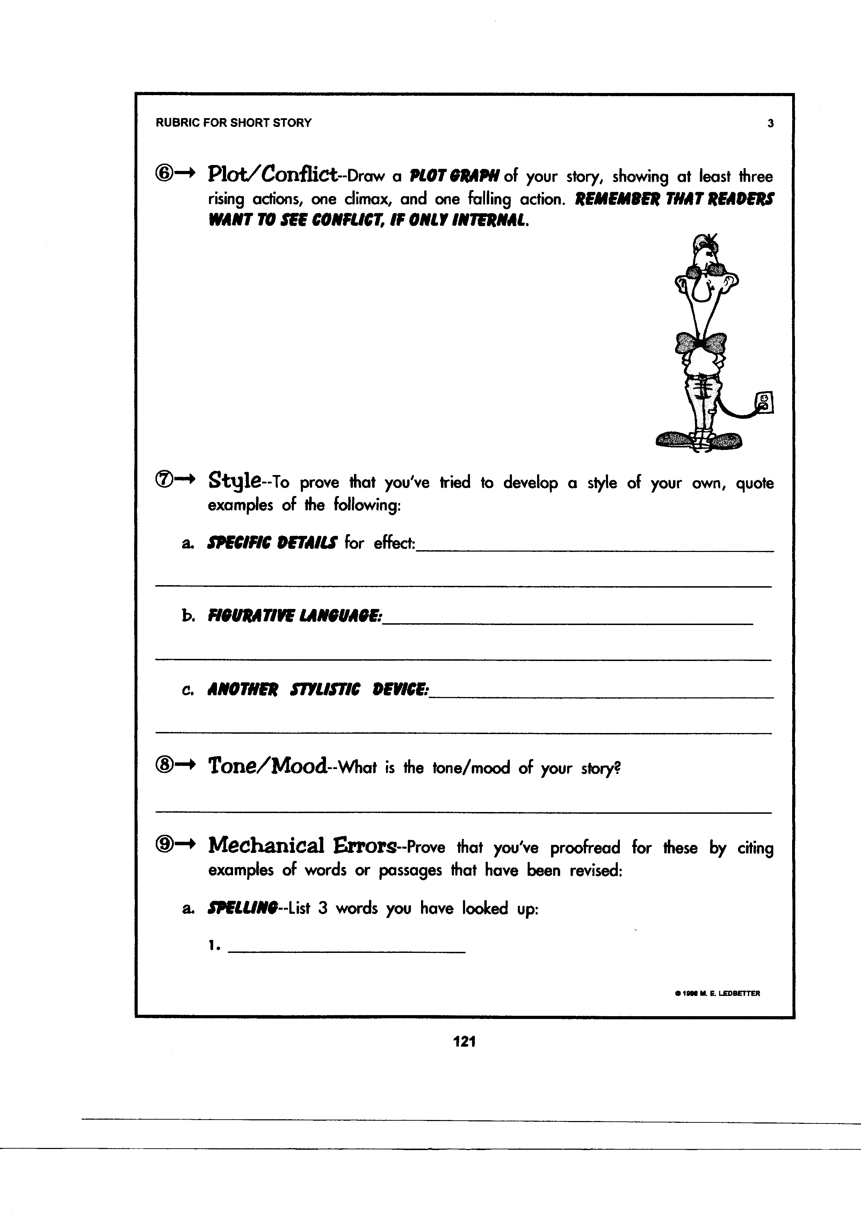

You must include figurative language in your story. Write an example of what you will use. (Personification, metaphor, hyperbole, simile, idiom, etc.
Include how the conflict is resolved.

Will use
- Conversation: write a dialogue between the main character and another character. Each character must speak twice and do not use the word “said”.

____________________________________________________________________________________

____________________________________________________________________________________

____________________________________________________________________________________

____________________________________________________________________________________

____________________________________________________________________________________

____________________________________________________________________________________

____________________________________________________________________________________

____________________________________________________________________________________

